AEPHY2024
Narrogin SHS Year 11 ATAR PHYSICS Name:
Task No: | 1b
Task Type: | Science Inquiry: Experiment Validation
Content: | Heating Processes
Task Description:  Time Allowed | Validation Test  Reading time: 5 minutes  Working time: 45 minutes
Weighting: | 4%
Materials required | Physics Data Sheet, pens, pencils (including coloured), sharpener, correction fluid, eraser, ruler, highlighters, scientific calculator

Section | Mark | Percent
Lab report | /14 | ____%
Validation test | / 31 | ____%
Total:
____%

Question 1 (5 marks)

Consider the image below of two readings (in degrees Celsius) made by the same thermometer.
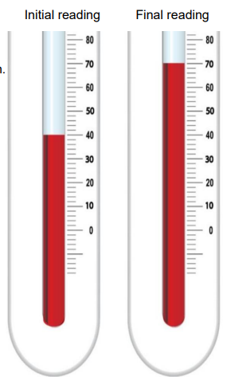
- Enter the measurements into the table below include a measure of uncertainty.
(2 marks)
- Convert the measurements in the first column to Kelvin. Place your answer in the final column.
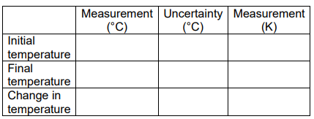
(1 mark)

- Calculate the percentage uncertainty of the change in temperature. (2 marks)

Question 2 (5 marks)

State the definitions of the following terms:
(2 marks)
- Thermal equilibrium

- Heat

Consider a spa containing 5.00 x 10² kg of water at 30.0 °C and a cup of 0.400 kg of water at 70.0 °C.

- State and explain, making reference to the terms “ heat” and “temperature”, the direction that thermal energy would flow if a person was to place his hand ( of surface temperature 35.0 °C) in both bodies of water.
(3 marks)

Question 3 (5 marks)

0.25kg of water at 20.0 °C is placed into a 0.500kg aluminium pan fresh off the stove with a temperature of 150 °C. Assuming that the pan is on an insulated pad and that no significant amount of water boils off, calculate the final temperature of the water and pan system.
c_{Al} = 900 J kg⁻¹ K⁻¹

Question 4 (7 marks)

An ice cube at 0.00 °C is placed into an insulated container with 151 g of water at 45.0 °C. In one minute, the ice cube had melted. The final mass of water in the glass was 175 g and the final temperature of the water was 28.0 °C.

- Using the data provided, calculate the latent heat of fusion of water.
(5 marks)

- Calculate the percentage error compared with the accepted value.
(2 marks)

Question 5 (9 marks)

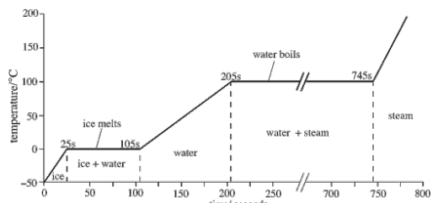
Consider the heating curve of 0.100 kg of water shown below.

- Calculate the energy required to fully melt the ice.

- Calculate the energy required to heat the water from the 105 second mark to 205 second mark.

- Using the values obtained in part (a) and (b), determine if heat is supplied at a constant rate throughout the heating curve.

